河南德宜瑞新材料有限公司
Henan Deyirui New Material Co.,LTD
产品目录 Product catalog
序号No | 名称  Name | 资料  Data | 性状及应用  Appearance and application | 分子结构图  Molecular structure diagram | 图片  Photo
1 | 分散黄54#  Disperse Yellow 54 | 分子式(Molecular formula)：C₁₈H₁₁NO₃  CAS NO：12223-85-7  EINECS NO:  231-474-9 | 黄色粉末。  可用于涤纶、锦纶、醋纤、涤/毛混纺织品的染花和印色，也可作为有机颜料使用，是高效、安全、环境友好型染料。适用于高温高压法以及常温染色和常温载体法染色或印花，匀染性能较好，日晒牢度高。作为三原色之一，可染单色，也可与别的染料复配成其他颜色。  Yellow powder.  It can be used for dyeing and printing of polyester, nylon, vinegar fiber, polyester / wool blended textiles, and also as organic pigment. It is a high-efficiency, safe and environmentally friendly dye. It is suitable for dyeing or printing by high temperature and high pressure method, normal temperature dyeing and carrier method. It has good levelness and high fastness to sun. As one of the three primary colors, it can be dyed in monochrome or mixed with other dyes to other colors. | 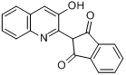 | 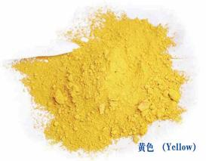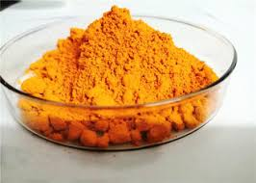
2 | 溶剂黄114#  Solvent Yellow 114 | 分子式(Molecular formula)：C₁₈H₁₁NO₃  CAS NO：  75216-45-4  EINECS NO:  231-474-9 | 橙黄色粉末  可用于油墨、塑料、树脂，橡胶、蜡烛等的着色，也可作为有机颜料使用，是高效、安全、环境友好型染料。色光鲜艳，耐高温性能好，匀染性能好，日晒牢度可达 6-7 级，是三原色之一。  Orange powder  It can be used for coloring ink, plastic, resin, rubber, candle, etc. it can also be used as organic pigment. It is an efficient, safe and environment-friendly dye. It is one of the three primary colors with bright color, good high temperature resistance, good level dyeing performance, light fastness up to 6-7 grade. | 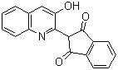 | 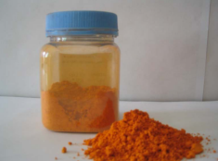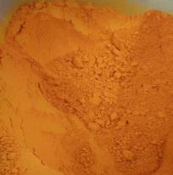
3 | 分散黄64#  Disperse Yellow 64 | 分子式(Molecular formula)：  C₁₈H₁₀NO₃Br  CAS NO：  10319-14-9  EINECS NO:  233-701-7 | 深橙色粉末  主要用于涤纶染色，可得艳亮的纯黄色，日晒牢度优良，遮盖性较好，是染中、浅色的主要染料。也可用于锦纶、醋酸纤维的染色。作为三原色之一，可与分散红3B(或分散红FB)、分散蓝2BLN(或分散蓝E-4R )组成三原色，匀染性好，配伍性好，色光稳定。也用于涤纶绸的直接印花；用于涤毛混纺产品染色时羊毛沾色少。  Dark orange powder  It is mainly used for polyester dyeing, with bright pure yellow, good fastness to sunlight and good covering. It is the main dye for medium and light colors. It can also be used for dyeing nylon and acetate fiber. As one of the three primary colors, it can be combined with Disperse Red 3B (or disperse red FB) and disperse blue 2BLN (or disperse blue FBL) to form three primary colors with good levelness, good compatibility and stable shade. It is also used for direct printing of polyester fabrics; When it is used for dyeing polyester wool blended products, the staining of wool is less. | 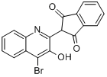 | 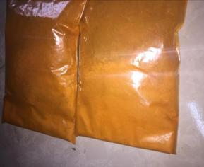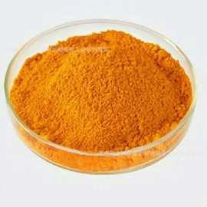
4 | 溶剂黄176#  Solvent Yellow 176 | 分子式(Molecular formula)：  C₁₈H₁₀NO₃Br  CAS NO：  10319-14-9  EINECS NO:  233-701-7 | 黄色粉末  可用于油墨、塑料、树脂，橡胶、蜡烛等的着色，也可作为有机颜料使用，是高效、安全、环境友好型染料。色光鲜艳，耐高温性能优异，匀染性能好，日晒牢度可达 6-7 级，是三原色之一。  Yellow powder  It can be used for coloring ink, plastic, resin, rubber, candle, etc. it can also be used as organic pigment. It is an efficient, safe and environment-friendly dye. It is one of the three primary colors with bright color, excellent high temperature resistance, good level dyeing performance, light fastness up to 6-7 grade. | 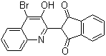 | 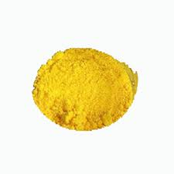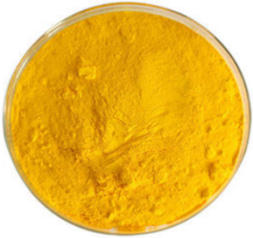
5 | 盐酸氨溴索  Ambroxol Hydrochloride | 分子式(Molecular formula)：  C₁₃H₁₈Br₂N₂O ·HCl  CAS NO：  23828-92-4  EINECS NO:  245-899-2 | 白色结晶粉末  可用于治疗痰液分泌异常、咳痰功能差的急慢性呼吸道疾病的祛痰药的原料。  White crystalline powder  It can be used as the raw material of expectorant for the treatment of acute and chronic respiratory diseases with abnormal sputum secretion and poor expectoration function. | 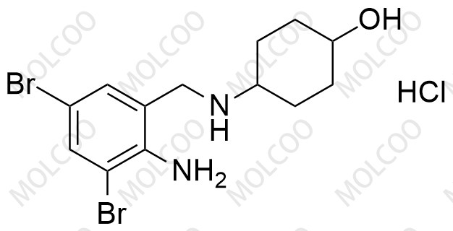 | 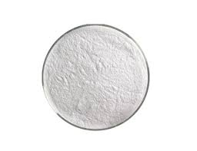  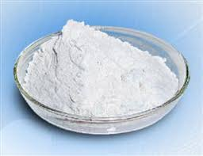
6 | 邻氨基苯甲醇2-Aminobenzylalcohol | 分子式  (Molecular  formula)：  C₇H₉NO  CAS NO：  5344-90-1  EINECS NO:  226-293-7 | 米色或灰棕色结晶粉末  用于染料、医药  Beige or grayish brown crystalline powder  Used in dyestuff and medicine. | 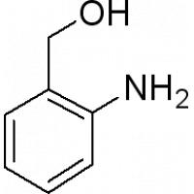 | 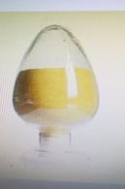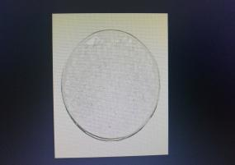
7 | 邻氨基苯甲醛  2-Aminobenzaldehyde | 分子式(Molecular formula)：  C₇H₇NO  CAS NO：  529-23-7  EINECS NO:  208-454-3 | 淡黄色或近无色针状或片状结晶  有机合成中间体；用于染料、医药。  Light yellow or nearly colorless needle or flake crystal  Organic synthesis intermediate; Used in dyestuff and medicine. | 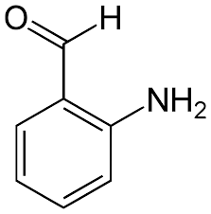 | 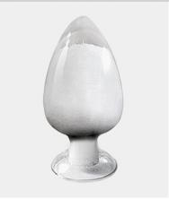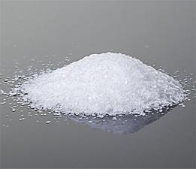
8 | 喹啉-2-甲酸  Quinaldic acid | 分子式(Molecular formula)：  C₁₀H₇NO₂  CAS NO：  93-10-7  EINECS NO:  202-218-3 | 类白色结晶性粉末  有机合成中间体，应用于医药、农药、有机化学等领域  White like crystalline powder  Organic synthesis intermediates, used in medicine, pesticides, organic chemistry and other fields. | 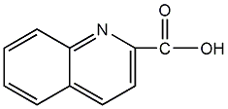 | 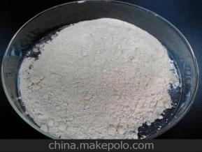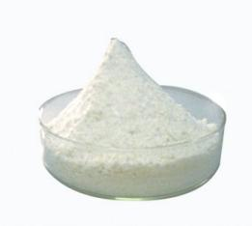
9 | 3,5-二溴邻氨基苯甲醛  3,5-Dibromoanthranilaldehyde | 分子式(Molecular formula)：  C₇H₅Br₂NO  CAS NO：  50910-55-9 | 淡黄色晶体粉末  盐酸氨溴索的中间体  Yellowish crystal powder  Intermediate of ambroxol hydrochloride | 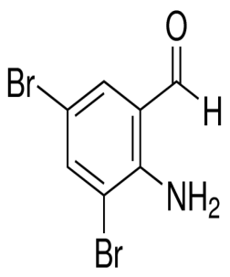 | 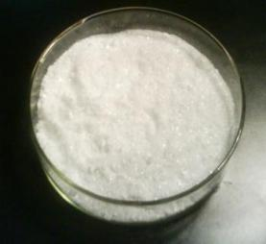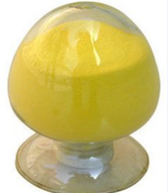

产品描述（分散黄54） Product Description(disperse yellow 54)
外观 Appearance | 黄色粉末 yellow powder
强度 Strength（%） | 460
CAS号 CAS No. | 12223-85-7
闪点Flash Point（°C） | 257.4
含量 content（%） | ≥98.0
干燥失重 Loss on drying（%） | ≤0.5
PH值 pH Value | 5--6
EINECS 号 EINECS No. | 231-474-9
等级标准 Grade Standard | 工业级 Industrial Grade

产品描述（分散黄64）Product Description(disperse yellow 64)
外观 Appearance | 黄色粉末 yellow powder
强度 Strength（%） | 400
CAS号 CAS No. | 10319-14-9
含量 content（%） | ≥98.0
干燥失重 Loss on drying（%） | ≤0.5
PH值 pH Value | 5-6
EINECS 号 EINECS No. | 233-701-7
等级标准 Grade Standard | 工业级 Industrial Grade

检测项目  Items  产品名称  Product Name |  | 色光  Chromatic light | 强度  Strength  (%) | 水分  moisture content（%） | PH值  pH value | 铁离子  Iron ion content（ppm） | 电导率  Conductivity  （µs/cm） | 外标  External standard  (%) | DMF不溶物  DMF insolubles  （%） | 灰分 Ash content（%） | 压力值  Pressure value  (MPa) | 用 途  Use
普品  General products | 指标  Iindex | 近似、微  Approximate, micro | ≥460 | ≤0.5 | 5.0-7.0 | ≤10 | ≤50 | ≥99.0 | ≤0.15 | ≤0.2 | 无  Be without | 滤饼、塑料塑胶、  色母料  Filter cake, plastic, color masterbatch
 | 随机实测Random measurement | 近似、微  Approximate, micro | 460 | 0.05 | 5.16 | 6.69 | 35.1 | 99.27 | 0.08 | 0.11
精品  Fine products | 指标  Iindex | 近似、微  Approximate, micro | ≥460 | ≤0.5 | 6.0-8.0 | ≤10 | ≤30 | ≥99.5 | ≤0.1 | ≤0.1 | 无  Be without | 墨水、喷墨、数码印花、高端色母（医用、航空）Ink, inkjet, digital printing, high end color masterbatch (medicine, aviation)
 | 随机实测Random measurement | 近似、微  Approximate, micro | 460 | 0.03 | 6.23 | 5.36 | 25 | 99.59 | 0.02 | 0.02
优品Excellent products | 指标  Iindex | 近似、微  Approximate, micro | ≥460 | ≤0.5 | 6.0-8.0 | ≤10 | ≤20 | ≥99.5 | ≤0.1 | ≤0.1 | 0.2 | 拉丝  wire drawing
 | 随机实测Random measurement | 近似、微  Approximate, micro | 460 | 0.01 | 6.21 | 3.28 | 18 | 99.65 | 0.01 | 0.02 | 0.04
产品描述（溶剂黄114）Product Description（solvent yellow 114）

产品描述（溶剂黄176）Product Description（solvent yellow 176）
产品名称 Product Name | 溶剂黄176 Solvent yellow 176
外观 Appearance | 黄色粉末 Yellow Powder
熔点 Melting Point（°C） | >350
含量 content（%） | ≥99.0
电导率 Conductivity（µs/cm） | ≤30
铁离子 Iron ion content（ppm） | ≤10
DMF不溶物 DMF insolubles（%） | ≤0.1
水分 Moisture（%） | <0.5
PH值 PH value | 6-8
灰分 Ash（%） | <0.5
应用 Application | 用于油墨、喷墨、塑料、树脂、橡胶、蜡烛等的着色。  Used for coloring ink, inkjet，plastic, resin, rubber, candle, etc..

产品描述（盐酸氨溴索）Product Description（Ambroxol hydrochloride）
项目 items | 基本内容 substance
CAS号 CAS No. | 23828-92-4
名称 Names | 盐酸氨溴索 Ambroxol hydrochloride
分子式 MF | C₁₃H₁₈Br₂N₂O·HCl
EINECS 号 EINECS No. | 245-899-2
纯度 Purity（%） | ≥99.0
含量 content（%） | ≥99.0
外观 Appearance | 白色结晶粉末 white crystalline powder
熔点 Melting point（℃） | 235-- 240
PH值 PH value | pH(10g/l, 25℃) : 4.0～6.0
应用 Application | 中间体 intermediates
品牌 Brand Name | 德宜瑞 Deyirui
原产地 Place of Origin | 中国河南 Henan China
等级标准 Grade Standard | 工业级 Industrial Grade

邻氨基苯甲醇检测指标 Detection index of 2-Aminobenzylalcohol
名称  Name | 化学式  Chemical formula | CAS号  CAS number | EINECS号  EINECS No | 分子量  Molecular weight | 外观和性能  Appearance and properties | 纯度  Purity  （%） | 熔点  Melting point | 应用  Application
邻氨基苯甲醇  2-Aminobenzylalcohol | C₇H₉NO | 5344-90-1 | 226-293-7 | 123.152 | 米色或灰棕色结晶粉末  Beige or grayish brown crystalline powder | ≥99.0 | - 83  - (lit.) | 用于染料和医药  Used in dyestuff and medicine

邻氨基苯甲醛检测指标 Detection index of 2-Aminobenzaldehyde
名称  Name | 化学式  Chemical formula | CAS号  CAS number | EINECS号  EINECS No | 分子量  Molecular weight | 外观和性能  Appearance and properties | 纯度  Purity (%) | 熔点  Melting point（°C） | 应用  Application
邻氨基苯甲醛  2-Aminobenzaldehydel | C₇H₇NO | 529-23-7 | 208-454-3 | 121.14 | light yellow crystalline powder | ≥99.0 | 39-40  (lit.) | Organic synthesis intermediate; Used in dyestuff and medicine.

产品描述（喹啉-2-甲酸）Product Description（Quinaldic acid CAS:93-10-7）
项目 ITEMS | 技术参数SPECIFICATIONS
外观 Appearance | 米白色或白色结晶性粉末 Off-white or white crystalline powder
CAS号 CAS No. | 93-10-7
纯度 Purity(%) | ≥99.0
熔点 Melting point(℃) | 156~~158
灰分 Ash(%) | ≤0.5
干燥失重 Loss on drying(%) | ≤0.1

产品描述（3,5-二溴邻氨基苯甲醛）Product Description（3,5-Dibromoanthranilaldehyde CAS:50910-55-9）
项目 ITEMS | 技术参数 SPECIFICATIONS
外观 Appearance | 黄色粉末Yellow powder
CAS号 CAS No. | 50910-55-9
纯度 Purity(%) | ≥99.0
熔点 Melting point(℃) | 136~~140
干燥失重 Loss on drying(%) | ≤0.5
单一杂质 Single impurities(%) | ≤0.2
总杂质 Total impurities(%) | ≤0.5

